Princess Sumaya University for Technology

King Abdullah II Faculty of Engineering



**MICROPROCESSORS AND EMBEDDED**

**SYSTEMS PROJECT**

**Juice Machine**

|  |  |  |  |  |  |
| --- | --- | --- | --- | --- | --- |
| |  | | --- | | *Supervisor:* | | Dr.Belal Sababha | | Dr. Esam Qaralleh | | Eng.Saad Al-zoubi | | |
| |  |  |  | | --- | --- | --- | | Authors: | ID |  | | Mohammed abumathana | 20210583 | IOT Eng. | | Ibrahim methaq | 20210654 | NIS Eng. | | Abdullah alawneh | 20201061 | electonics Eng | | |
|  |  | |  |

***Abstract***

This project presents an automated juice dispensing system built using the PIC16F877A microcontroller. It integrates various sensors and actuators, including ultrasonic and infrared sensors, a servo motor, a pump, and an LCD display to deliver a user-friendly and efficient juice dispensing experience. The system detects the presence of a cup, monitors juice levels, and dispenses a precise amount of juice automatically. A manual mode is also available for continuous flow. Real-time status is displayed on the screen, and safety mechanisms are in place to prevent operation without a cup or when the tank is empty. This project demonstrates the practicality of embedded systems in enhancing automation and user interaction in everyday applications.

**TABLE OF CONTENTS**

1 INTRODUCTION 2

1.1 OBJECTIVES 2

2 DESIGN 3

2.1 MECHANICAL DESIGN 3

2.2 ELECTRICAL DESIGN 4

2.3 SOFTWARE DESIGN 5

3 RESULTS 6

4 PROBLEMS AND RECOMMENDATIONS 8

5 CONCLUSIONS 8

6 REFERENCES 9

# INTRODUCTION

The integration of embedded systems and automation technologies has revolutionized how routine tasks are performed, particularly in food and beverage services. These systems improve efficiency, reduce manual intervention, and enhance user interaction through intelligent control mechanisms.

This project demonstrates the application of the PIC16F877A microcontroller in designing an automated juice dispensing machine. By incorporating ultrasonic and infrared sensors, a pump, and servo mechanisms, the system ensures precise juice delivery, user safety, and intuitive operation. It highlights how embedded systems can provide practical, low-cost solutions in consumer service environments by automating repetitive tasks with accuracy and reliability

## OBJECTIVES

* Demonstrate the role of embedded systems in automating beverage dispensing processes using the PIC16F877A microcontroller.
* Implement sensors (ultrasonic and IR) to monitor juice levels and detect the presence of a cup, ensuring safe and accurate operation.
* Develop an automatic and manual control system for juice dispensing based on user input and sensor feedback.
* Design a user-friendly LCD interface to display real-time status messages and alerts for improved usability.
* Ensure reliable power and component integration for consistent performance of the entire system.

# DESIGN

In this section we will show our design from different sides (Mechanical – Electrical – Software):

## MECHANICAL DESIGN

In our mechanical design, we focused on simplicity and efficiency. The system uses a compact setup to house components, ensuring neat wiring and accessibility. The juice tank is securely positioned, and the pump and servo motor are mounted for stable and accurate operation.

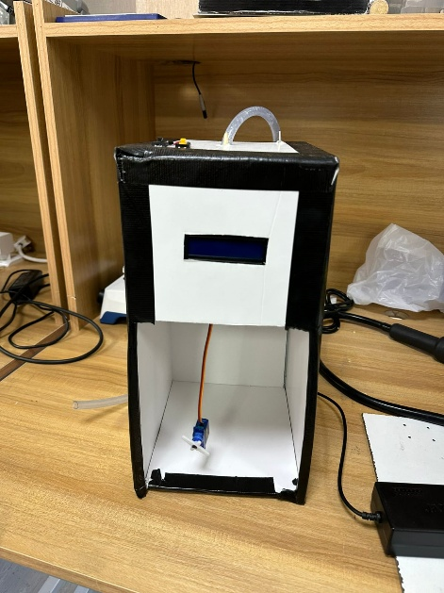

Figure 1. Mechanical Design (1)

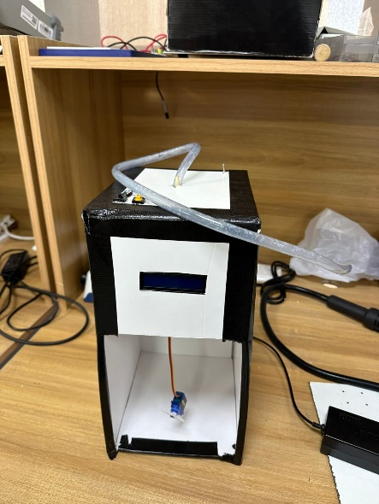

Figure 2. Mechanical Design (2)

## ELECTRICAL DESIGN

In the electrical design, an ultrasonic sensor monitors the juice level in the main tank, while two IR sensors detect the presence of a cup. A servo motor opens and closes the tank valve, and a pump dispenses juice into the cup. The PIC16F877A microcontroller processes input from the sensors and manages actuator control, with a potentiometer adjusting pump speed. A 16x2 LCD displays system status, and the setup is powered by 3.7V batteries regulated for consistent and efficient operation.

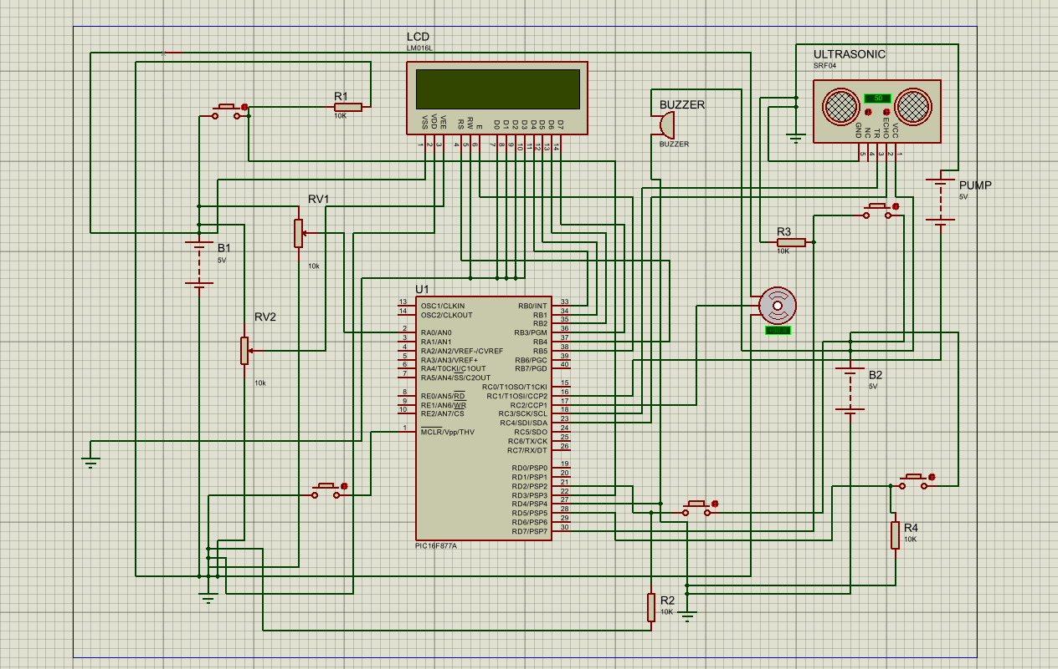

Figure 3. Electrical Design

## SOFTWARE DESIGN

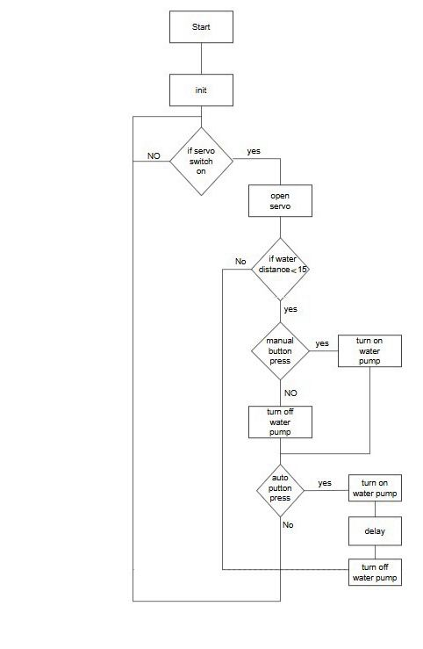This flow chart explains the flow of the program we used in our project.

Figure 4. Software Design

# RESULTS

We were able to achieve all of the desired functionalities within this project, and this is our last prototype:

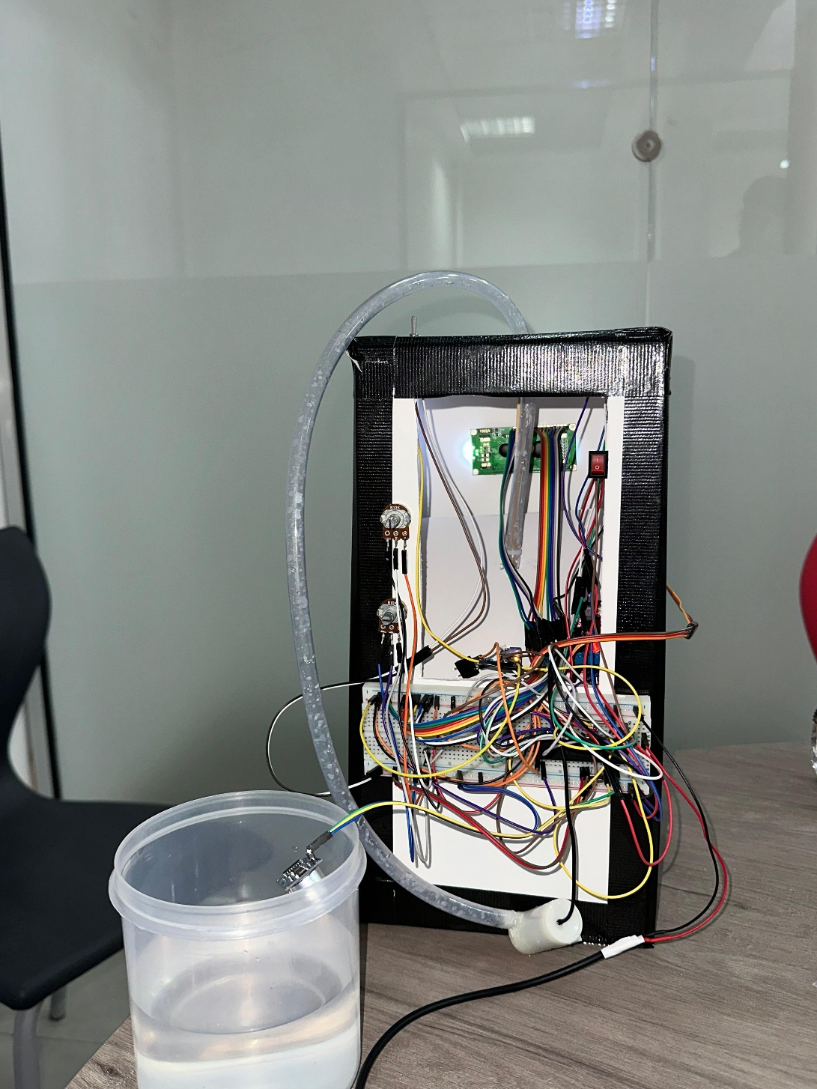

Figure 5. Final implementation (1)

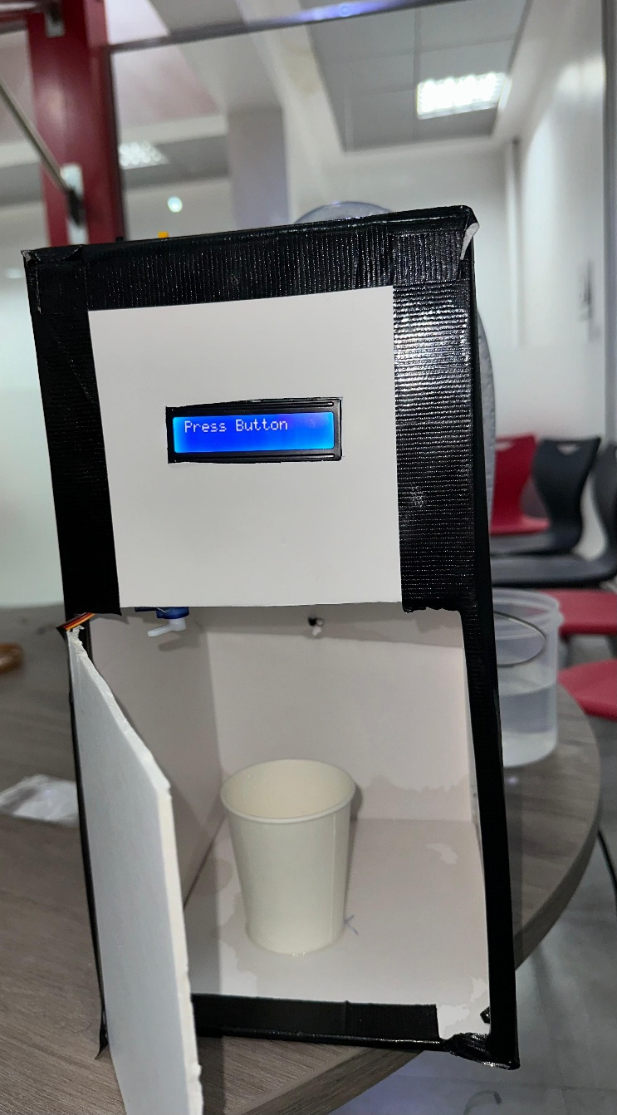

Figure 6. Final implementation (2)

**GitHub Link:**

**Youtube Link:** [juice machine porject](https://youtube.com/shorts/RnsWB-YRyCE?feature=shared)

# PROBLEMS AND RECOMMENDATIONS

During the implementation of our dual-tank automated monitoring system, we faced several challenges that required troubleshooting and adaptation. Below are the key problems we encountered and how we addressed them:

1. Initial wiring and pin assignments on the PIC16F877A created confusion due to overlapping connections. After reviewing the datasheet and testing configurations, we reorganized the circuit layout to minimize conflicts and improve stability.
2. The servo motor controlling the tank cover was difficult to calibrate. At first, it produced inconsistent movement. By adjusting PWM values and fine-tuning the pulse width, we achieved smooth and reliable operation for opening and closing.
3. The IR sensors occasionally gave false readings when detecting the cup. This issue was solved by repositioning the sensors for better alignment and applying a delay in the code to filter out noise from ambient light or movement.

# CONCLUSIONS

This project demonstrated the potential of embedded systems in addressing real-world needs by automating the juice dispensing process. The successful integration of sensors, a microcontroller, and actuators resulted in a dependable system capable of detecting cup presence, monitoring juice levels, and delivering precise output. By overcoming key design and implementation challenges, we achieved a functional and user-friendly solution that aligns with the project’s goals.

Beyond the technical accomplishments, this project offered valuable experience in embedded system design, sensor integration, and real-time decision-making. It lays the groundwork for future improvements, such as touchless operation, wireless monitoring, and expanded customization, making the system adaptable for commercial or self-service environments.

# REFERENCES

1. https://github.com
2. PSUT E-Learning